Instructions for Assembly: STEM of Kicking Module

Materials

(see the materials list for brands and vendors)
Each kicking kit requires:  - 2 jumbo craft sticks  - 3 #10-32 x 1” machine screws  - 6 #10 nuts  - 3 different-sized rubber bands | 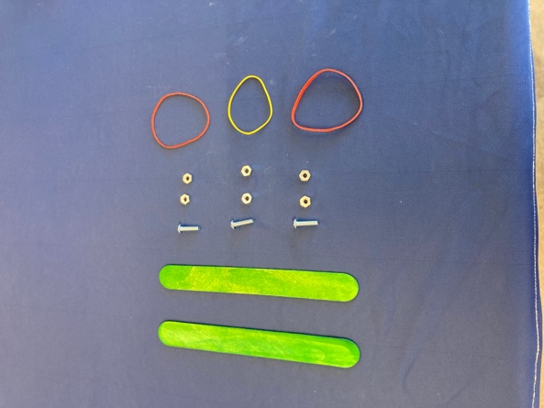

Shared Resources include:  - Heavy Duty 3-hole punch  - Transparent tape | 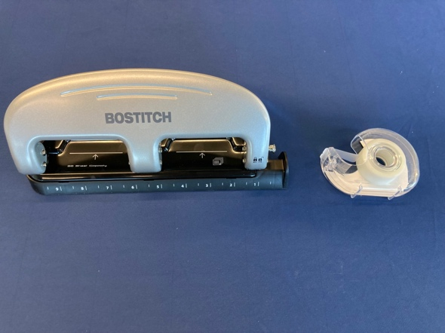

Step 1: Punch holes in both ends of both jumbo craft sticks.

For best results, punch one end of one jumbo stick at a time. | 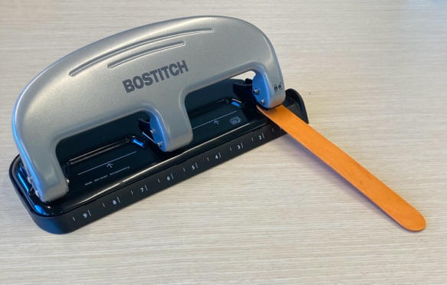
If your sticks splinter during punching, tape the ends before you attempt to punch the hole. | 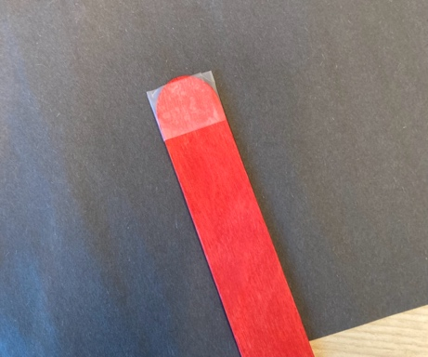
If the jumbo stick splintered when you punched the whole, leave the tape on for the rest of the steps.  If the jumbo stick has not splintered, you can remove the tape. | 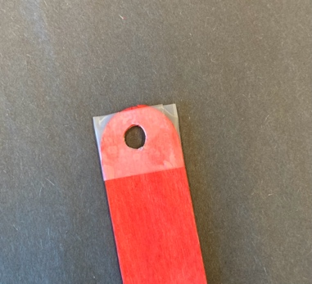
At the completion of Step 1, you should have two jumbo sticks, each with a hole in both ends. | 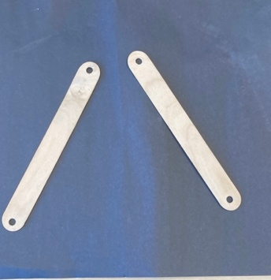

Step 2: Connect the jumbo sticks with machine screws and nuts.

Form the “knee” by connecting the two jumbo sticks with a machine screw and two nuts.  Leave some space between the two nuts to fit the rubber band.  Do not tighten the first nut so tight that the “knee” does not swing. | 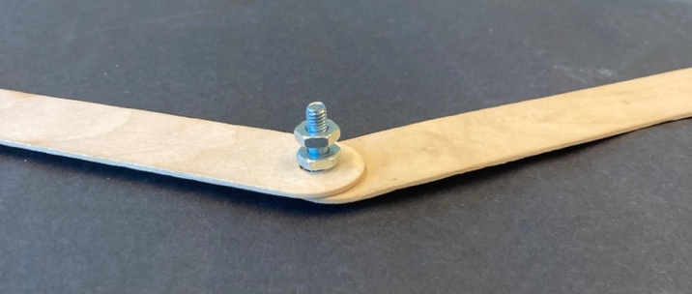
Add a machine screw and two bolts to the other ends of the leg.  Leave some space between the two nuts to fit the rubber band.  Make sure both screws are “pointing” in the same direction. | 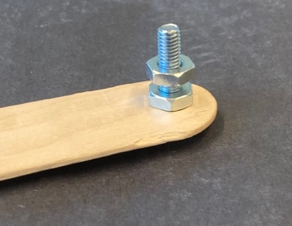 | 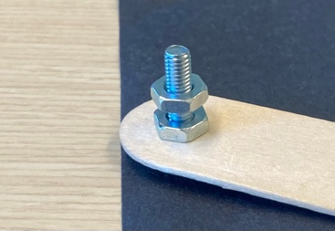
At the completion of this step, you should have two connected jumbo sticks and are now ready to add the rubber band. | 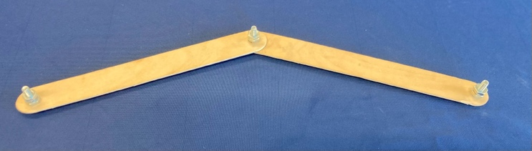

Step 3: Connect the rubber band to simulate the muscles.

Connect the rubber band to the ends of the jumbo stick, making sure the rubber band is between the two nuts. You can tighten the second nut down to secure the rubber bands.  Loop both sides of the rubber band over the same side of the knee screw.  Do not tighten the knee’s second nut. The rubber band must be able to stretch. | 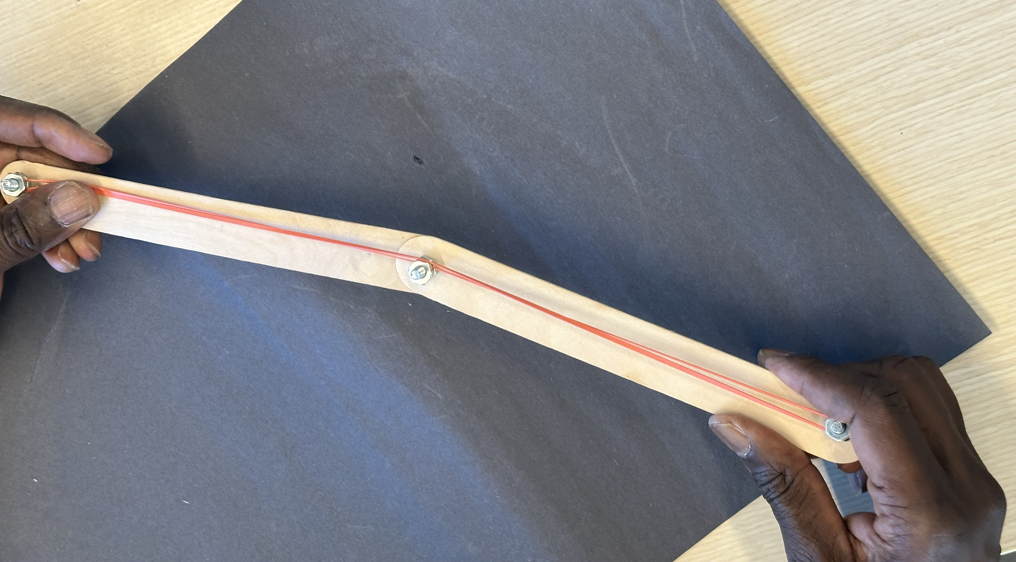

Done!
You now have a working leg, capable of kicking.
Simply bend your leg, then release to “kick”.
Change the rubber band to see how that stiffer rubber bands change the kicking power.

